CONTENT AND WIREFRAMES: 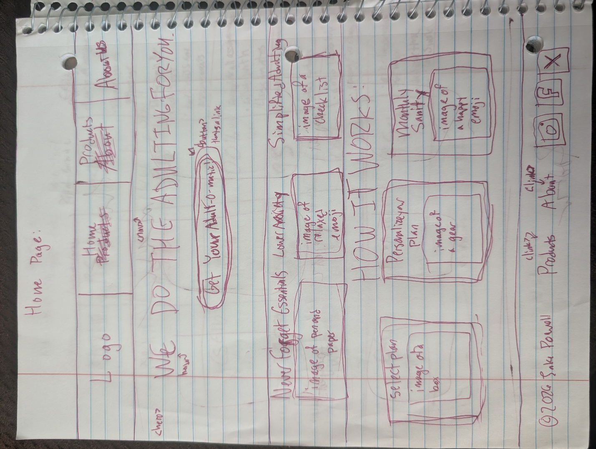
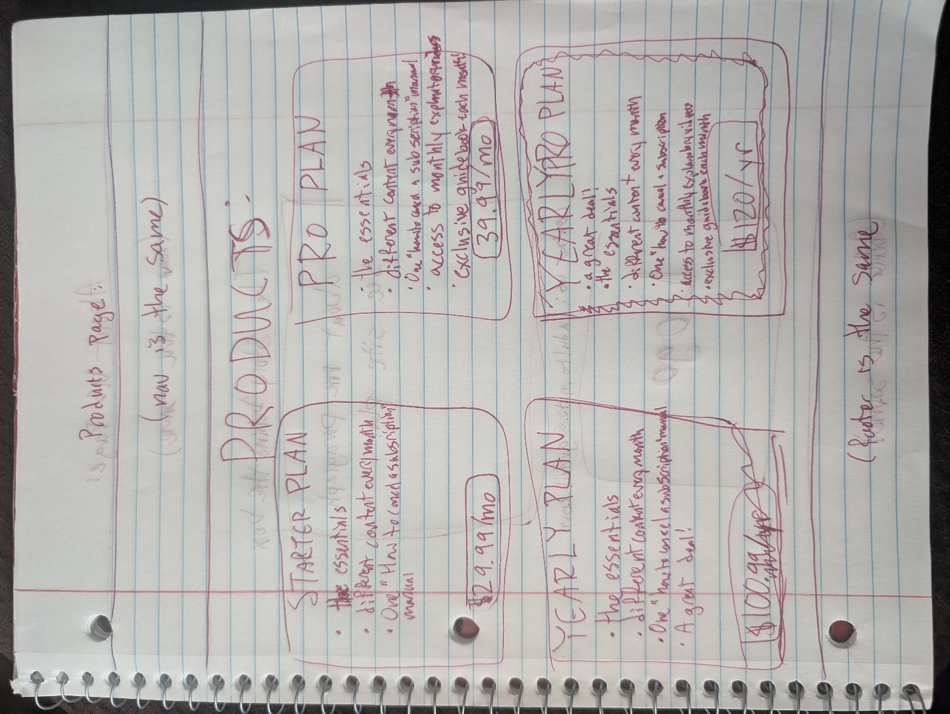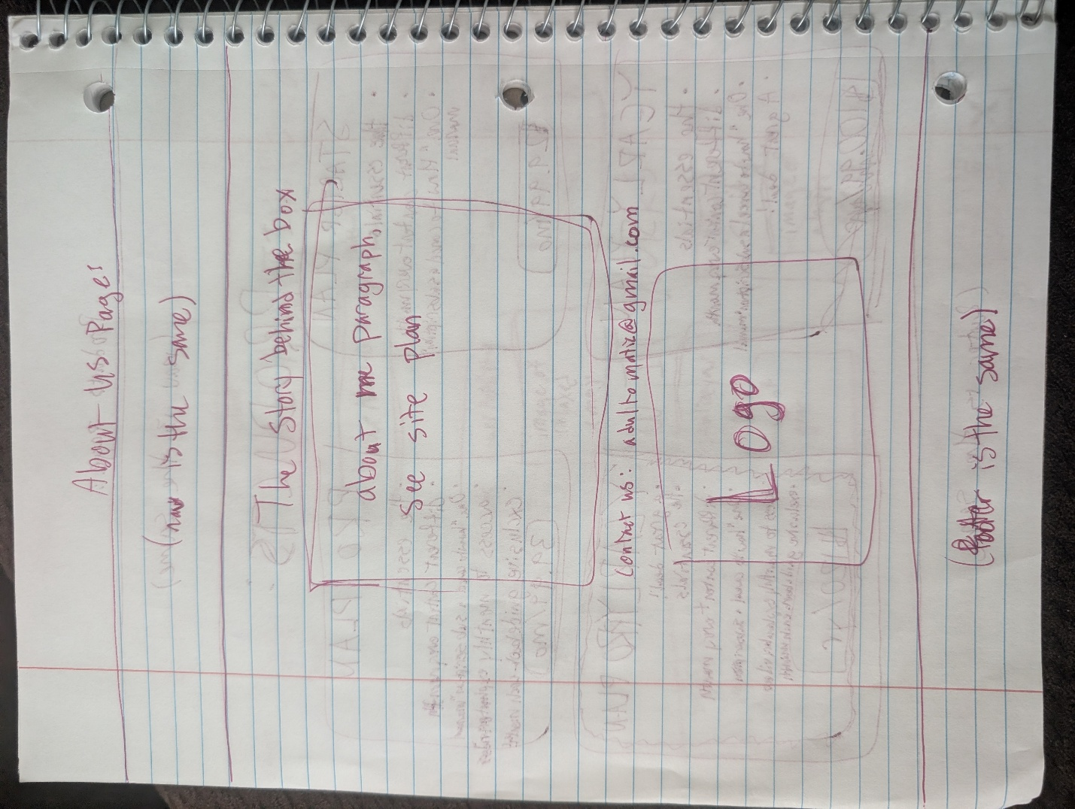

ABOUT ME PARAGRAPH:
I spent the better part of my twenties realizing that "being an adult" is mostly just a series of high-stakes chores I never actually signed up for. After one too many 2:00 AM Google searches on how to properly defrost a freezer—and a truly embarrassing amount of time spent looking for a single envelope—I realized that the problem wasn't me; it was the lack of a manual. I created Adult-O-Matic because I believe your mental energy is better spent on your passions, your career, and your actual life, rather than wondering when you last changed your air filter. I’m not here to be your life coach; I’m just here to make sure you have the right tools to pretend you have it all together, one subscription box at a time.

PURPOSE & AUDIENCE:
This website and product is intended to appeal to adults who are just starting to “adult”. In other words, it serves as a guide for people who need / want help figuring out how to do basic everyday things. The website will serve as an informational guide for those investigating this product, and it will help users understand the appeal and further convince them to purchase this product.

LOGO:
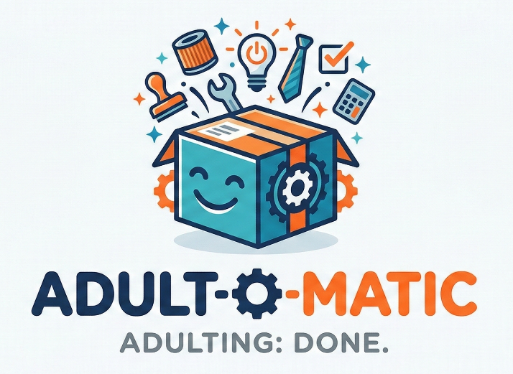

COLORS:
Header: Deep Navy (#0F1D36) background with White (#FFFFFF) navigation text.
Hero Section: Pure White (#FFFFFF) background. Bold Navy (#0F1D36) headline. A very prominent Vibrant Orange (#FD853A) 'Get Started' button.
Feature Section: Petrol Teal (#1A7B8B) background with White text and icons (wrench, lightbulb, etc.).
How It Works Section: Pure White (#FFFFFF) cards on a Section Gray (#F3F3F5) background. Body text in Body Gray (#B5B5B5).
Footer: Gray (#F3F3F5) with Deep Navy (#0F1D36) text links and copyright.

FONTS:
For Titles / headers / navigation: Century Gothic
For explanations / paragraphs: Georgia

